**COMPUTER SCIENCE DEPARTMENT**

Computer Organization and Assembly language (LAB)

**Lab Task # 09**

**Last date of Submission: 12th May 2024**

# Submitted To: Sir Akhtar Saleem

**Student Name: UBAID-BIN-WARIS**

# Reg. Number: 2212416

# 

**Question no 1.**

Write a program to calculate the occurrence count of the character 'o' within a string stored in memory. The character $ should be assumed as string termination character. For simplicity, let the string be: "A quick brown fox jumps over the lazy dog $".

**Code**

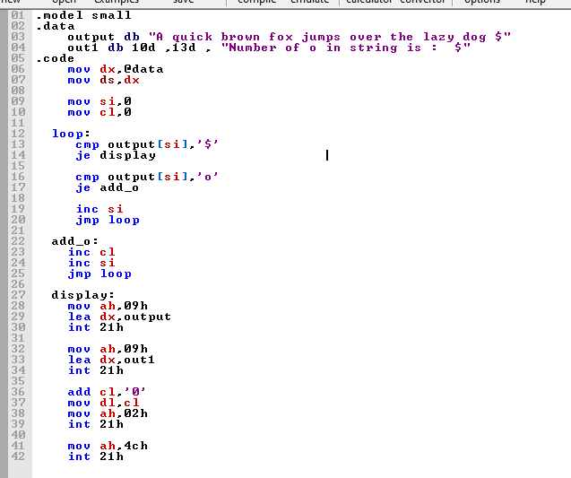

**Output**

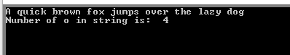

**Question no 2.**

Develop a to retrieve the current system time. Based on the retrieved time, it displays the message “It is news time.” if the time ranges between 9:00 PM and 10:00 PM. Otherwise, displays “It is not news time.”

**Code**

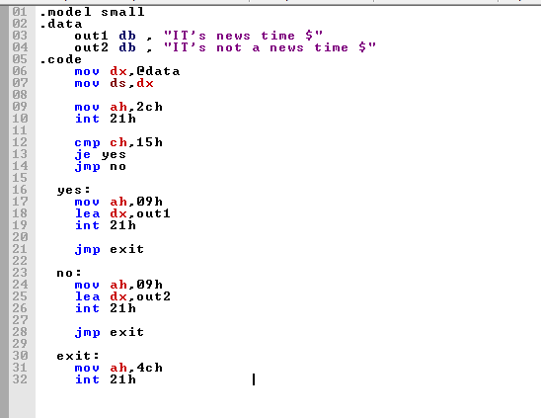

**Output**



